Directions: The goal of the following problems is to help challenge and deepen your understanding of the current topic. Don’t assume that you will know how to answer every question. You will work with at least two other students in the class to try and find solutions and write arguments for each of the following questions. Be sure that you question your classmates’ reasoning. If you don’t understand how they are getting something, you should ASK THEM TO EXPLAIN! Being able to defend your reasoning is important and so you are actually helping them by asking them to explain.

Challenge Questions

- Consider the region given by the following curves: .
- When the region is rotated about the y-axis determine if you need dx or dy integrals for washers/disks and for shells.

- Set up, but do not evaluate, a dy and a dx integral(s) that represent the volume of the resulting solid.

- Consider the region given by the following curves: .
- When the region is rotated about the line determine if you need dx or dy integrals for washers/disks and for shells.

- Set up, but do not evaluate, a dy and a dx integral(s) that represent the volume of the resulting solid.

- Consider the region R which is bounded by the curves . Suppose that R is rotated around the line .

- Determine the volume of the resulting solid by integrating with respect to x.

- Determine the volume of the resulting solid by integrating with respect to y.

- In the diagram below, the equation of the curve and the equation of the line is . Let be the volumes of the solids obtained by revolving the shaded region bounded by the curve and line about the x-axis and y-axis, respectively. If then what is the value of m?
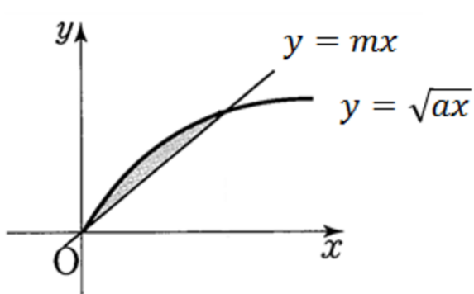

- The beads for a bracelet are spheres of radius 5mm with a hold of radius 3mm drilled through the center so that they can be threaded together. What is the volume, in , of material removed from the bead when the hold is drilled?

